**HTML Test:**

1. **Create a webpage using following formats :**

* The basic components of an HTML file: file type, head, title, body
* Headers of different size
* Paragraphs of text
* Text of different fonts
* Text of different size
* Text of different colors
* An image without a link
* An image that links out to another page
* A hyperlink that is represented as text
* An ordered list
* An unordered list
* A list within a list
* A table with border color, radius , width etc.
* Data description list .

1. **Draw a table in following structure :**

Row-1:

* In the first cell add a text box .
* In the second Cell add a dropdown list.
* In the third cell add three radio buttons.
* In the fourt cell add a button.

Row-2:

* In the first cell add a password field .
* In the second Cell add a 4 checkboxes.
* In the third cell add a ordered list.
* In the fourt cell add a unordered list.

1

1. **Create the below page layout :**

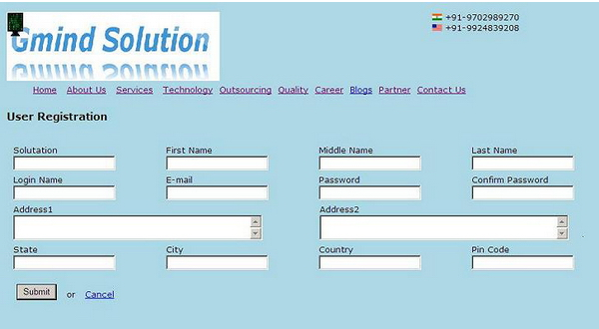

1. **Create below layout using external CSS**

